Journal of plant science & biosecurity

About the Journal:
The Journal of Plant Science & Biosecurity is an international, peer-reviewed, open-access journal dedicated to advancing scientific knowledge at the intersection of plant sciences, agriculture, biotechnology, and biosecurity. The journal provides a multidisciplinary platform for researchers, academicians, industry professionals, and policymakers to publish high-quality original research, review articles, short communications, case studies, and technical reports that address current and emerging challenges in plant health, crop improvement, sustainable agriculture, and biological risk management. It emphasizes innovative approaches that strengthen global food security while promoting environmentally responsible agricultural practices.
The journal welcomes submissions spanning plant physiology, molecular biology, genetics, genomics, plant pathology, crop science, plant breeding, biotechnology, precision agriculture, bioinformatics, climate-resilient agriculture, integrated pest management, biosafety regulations, invasive species management, plant disease surveillance, and agricultural biosecurity. By fostering interdisciplinary collaboration and the dissemination of cutting-edge research, the Journal of Plant Science & Biosecurity aims to support scientific innovation, enhance crop resilience, safeguard plant resources, and contribute to sustainable agricultural development and global biosecurity preparedness.
Latest News:
Crop Improvement & Gene Editing:-
Crop improvement and gene editing are transforming modern agriculture by enabling the development of high-yielding, climate-resilient, and disease-resistant crops. Advances in molecular breeding, genomics, and precision genome-editing technologies such as CRISPR-Cas systems, base editing, prime editing, TALENs (Transcription Activator-Like Effector Nucleases), and zinc-finger nucleases (ZFNs) have revolutionized the introduction of desirable traits with greater accuracy and efficiency while minimizing unintended genetic changes. These cutting-edge technologies are accelerating the development of crops with enhanced productivity, improved nutritional quality, increased tolerance to biotic and abiotic stresses, and greater resistance to pests and diseases, thereby contributing significantly to sustainable agriculture and global food security.

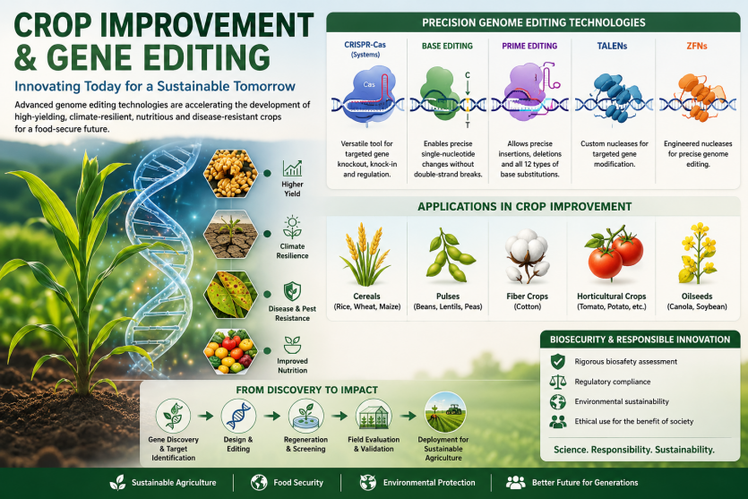

AI-Powered Crop Breeding Accelerates Climate-Resilient Agriculture:-
Researchers are increasingly combining artificial intelligence (AI), genomic prediction, and speed breeding to accelerate the development of crop varieties with improved yield, drought tolerance, and disease resistance. AI models are helping breeders identify beneficial genetic traits more rapidly, significantly reducing the time needed to develop climate-resilient crops.
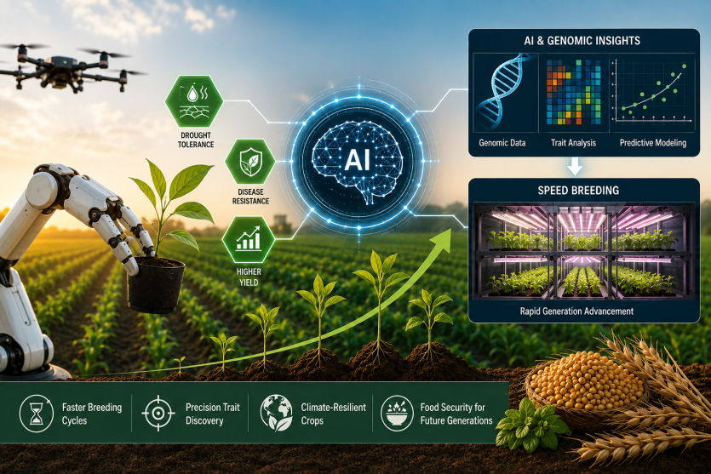

DNA Barcoding Advances Plant Taxonomy:-
Recent advances in DNA barcoding are transforming plant taxonomy by enabling faster and more accurate identification of plant species. Molecular techniques are helping researchers distinguish closely related and cryptic species that are difficult to identify using morphology alone. Combined with field ecology, these methods are improving biodiversity assessments and documenting previously unrecognized plant diversity. The resulting data support conservation planning, habitat restoration, and monitoring of threatened ecosystems. DNA-based taxonomy is also refining evolutionary relationships among plant groups and strengthening global plant classification systems. Together, these innovations are enhancing biodiversity research and guiding evidence-based conservation strategies.
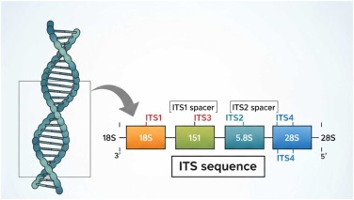

De Novo Domestication Expands Future Crop Diversity:-
Plant breeders are exploring de novo domestication, which involves improving wild plant species by introducing desirable agricultural traits while retaining their natural resilience. This strategy provides new opportunities to develop crops capable of thriving under drought, salinity, and other environmental stresses, offering an additional resource for sustainable agriculture and climate adaptation.
Scientific Topics:

- Agronomy and Agricultural Research
Agronomy and Agricultural Research focuses on improving crop productivity, soil health, and sustainable farming practices through scientific innovation. It encompasses crop management, plant nutrition, precision agriculture, and climate-smart technologies to enhance agricultural efficiency and resilience. The field plays a vital role in ensuring global food security while promoting environmentally sustainable agricultural systems.
- Horticulture and Floriculture
It encompass the science and technology of cultivating fruits, vegetables, ornamental plants, flowers, and landscape crops. The field incorporates advanced breeding, protected cultivation, precision horticulture, and post-harvest management to improve crop quality, productivity, and sustainability. It contributes significantly to food security, environmental conservation, and the growth of the global horticulture and floriculture industries.
- Medicinal Plants and Applications
Explore the discovery, cultivation, and utilization of plants with therapeutic and pharmaceutical value. Research in this field encompasses phytochemistry, pharmacognosy, herbal medicine, bioactive compounds, and medicinal plant biotechnology to support drug discovery and healthcare innovations. It also promotes the conservation, sustainable use, and scientific validation of medicinal plant resources for improving human health.
- Plant Ecology & Taxonomy
Plant Ecology and Taxonomy studies plant diversity, classification, evolution, and their interactions with ecosystems. Modern approaches such as molecular identification and DNA barcoding improve plant characterization and biodiversity assessment. This field supports conservation, ecological research, and sustainable management of plant resources.
- Plant Genetics & Molecular Biology
Plant Genetics and Molecular Biology explores the genetic mechanisms that control plant growth, development, and inheritance. Advances in genomics, gene editing, and molecular techniques are improving crop improvement and understanding plant traits. This field supports agricultural innovation, stress resistance studies, and sustainable plant biotechnology.
6. Plant Metabolic Engineering
Plant Metabolic Engineering involves modifying plant metabolic pathways to enhance the production of valuable compounds, improve traits, and increase crop quality. Advances in biotechnology and genetic tools enable the development of plants with improved nutritional, medicinal, and industrial applications. This field contributes to sustainable agriculture and the production of bio-based products.
7. Plant Nutrition and Soil Sciences
Plant Nutrition and Soil Sciences studies the relationship between soil properties, nutrient availability, and plant growth. Research in this field helps optimize fertilizer management, improve soil health, and enhance crop productivity. It supports sustainable agriculture through better nutrient use efficiency and ecosystem management.
8. Plant Pathology and Mycology
Plant Pathology and Mycology focuses on the study of plant diseases, fungal interactions, and mechanisms of pathogen infection. Research in this field supports the development of effective disease management strategies and crop protection methods. It contributes to sustainable agriculture by improving plant health and reducing yield losses.

- Plant Breeding techniques
Plant Breeding Techniques involve the development of improved plant varieties with desirable traits such as higher yield, disease resistance, and climate adaptability. Modern approaches, including marker-assisted selection, genomic breeding, and gene editing, accelerate crop improvement. These techniques support sustainable agriculture and global food security.
- Genetically Modified Crops
Genetically Modified (GM) Crops are developed by introducing specific genetic changes to enhance desirable traits such as pest resistance, improved nutrition, and stress tolerance. Advances in biotechnology enable precise crop improvement and increased agricultural productivity. GM crops contribute to sustainable farming and food security through improved crop performance.
11.Nanotechnology in Agriculture and Food Industry
Nanotechnology in Agriculture and Food Industry applies nanoscale materials and technologies to improve crop production, nutrient delivery, and food quality. It enables efficient use of fertilizers, targeted pest management, and advanced food packaging solutions. This field supports sustainable agriculture and enhances safety, productivity, and innovation in the food sector.
12. Agroforestry
Agroforestry integrates trees with crops and livestock systems to improve agricultural productivity and environmental sustainability. It enhances soil health, biodiversity, carbon storage, and climate resilience while providing additional economic benefits. This approach supports sustainable land management and ecosystem conservation.
Editorial in Chief:
Jeffrey T. Hutchinson
University of Texas at San Antonio, United States
Biography:
Dr. Jeffrey T. Hutchinson is an Associate Professor specializing in aquatic plant ecology, invasive species management, and freshwater ecosystem conservation. His research focuses on aquatic macrophytes, plant responses to environmental changes, biodiversity, and the ecological impacts of non-native species. He investigates plant-based indicators of ecosystem health, water quality, and sustainable management strategies. His work contributes to understanding plant–environment interactions and the conservation of aquatic and terrestrial ecosystems.
6 Articles are attached herewith….

